# Fertilizer Database

# Management System

*(A synopsis on the above mini project)*

Prepared by:

FARAZ SHABBIR SHAIKH (4NM17CS061)

KARTHIK U KUMAR (4NM17CS080)

5th Semester CSE (Section – B)

Introduction

All the nutrients in our food originally come from the soil. In order to create healthy crops full of nutrients, farmers need to work with healthy soil. Soils naturally contain many nutrients like nitrogen, phosphorous, calcium, and potassium. These nutrients allow plants to grow. When soil nutrients are missing or in short supply, plants suffer from nutrient deficiency and stop growing. When the nutrient level is too low, the plant cannot function properly and cannot produce the food necessary to feed the world’s population.

Farmers turn to fertilizers because these substances contain plant nutrients such as nitrogen, phosphorus, and potassium. Fertilizers are simply plant nutrients applied to agricultural fields to supplement required elements found naturally in the soil. Fertilizers have been used since the start of agriculture. Plants need to be fertilized because most soil does not provide the essential nutrients required for optimum growth.

Considering the importance of fertilizers in the production of crops, we have created a database that is used to store information about Fertilizers. This database will be useful for the farmers to find the best dealer for the fertilizer required and they’ll be able to communicate with Fertilizer dealers and buy the products. The farmer can keep track of fertilizer stock easily which will help him in invest calculations and also to prevent any malpractices.

Entity Relationship Diagram

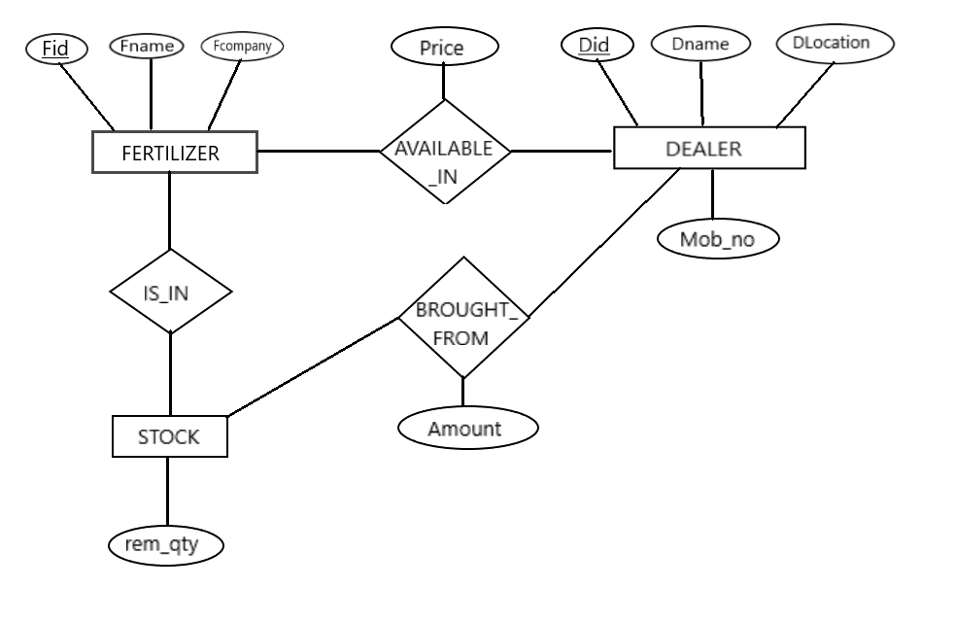

Relational Schema Diagram

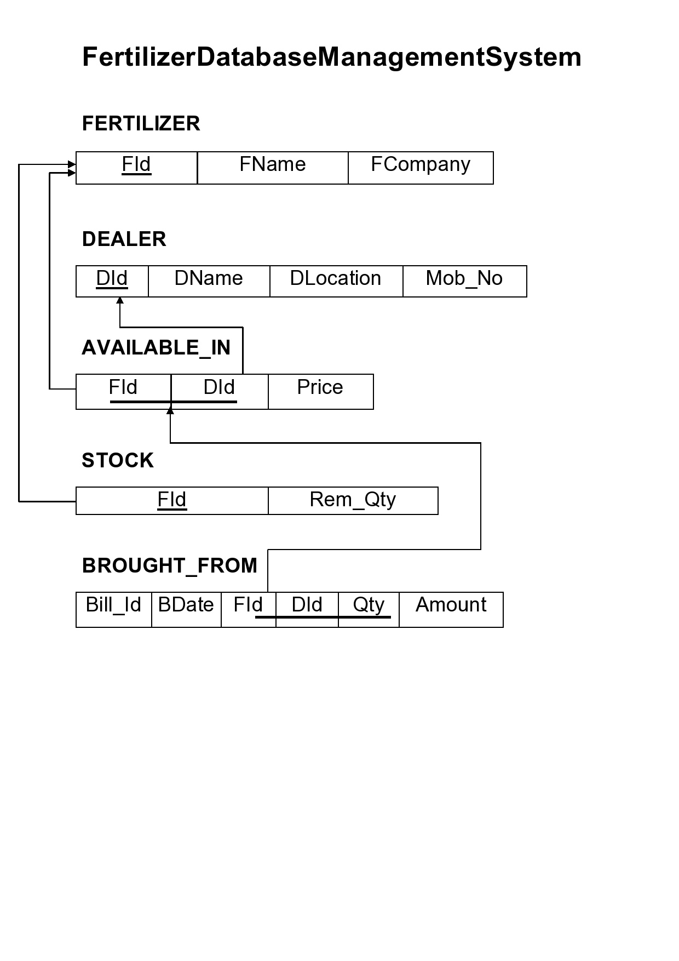

Software Requirements

1. Wampserver
2. JetBrains DataGrip (BackEnd Application)
3. Microsoft Visual Studio Code (FrontEnd Application)

Expected Outcomes

On completion of this project, we will have a database management system with following functionalities.

1. The software will enable farmers to retrieve the information of dealer who deals with a particular fertilizer.
2. The farmer can easily compare the prices of fertilizer with various dealers and would be able to save money by buying from the dealer who offers lesser price for the fertilizer.
3. The farmer will have details about the fertilizer stock he has with him.
4. There will be option for the user to update the usage of stock.
5. The previous fertilizer purchase details like bill amount, date, dealer from where the fertilizer was brought will be available to the user. It’ll be helpful for the farmer in stock management.
6. A user interface that will be easier for the farmer to operate and access the database without having more technical knowledge.